# Apache Spark Fundamentals

Data Science and Engineering Club

# Databricks Community Edition

Please sign-up for a free if you have not done so already:

[Databricks Community Edition account](https://accounts.cloud.databricks.com/registration.html#signup/community)

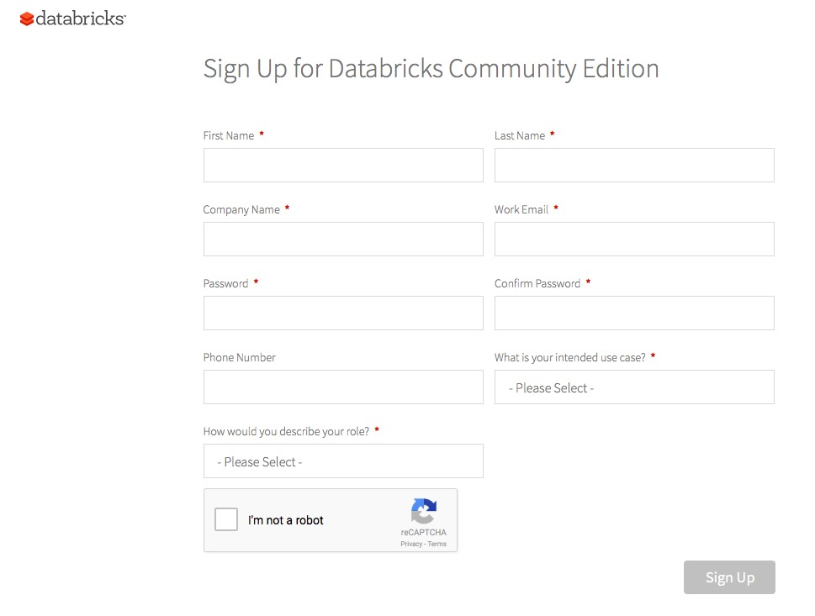

Login to Databricks Coummunity Edition:

[community.cloud.databricks.com](http://community.cloud.databricks.com)

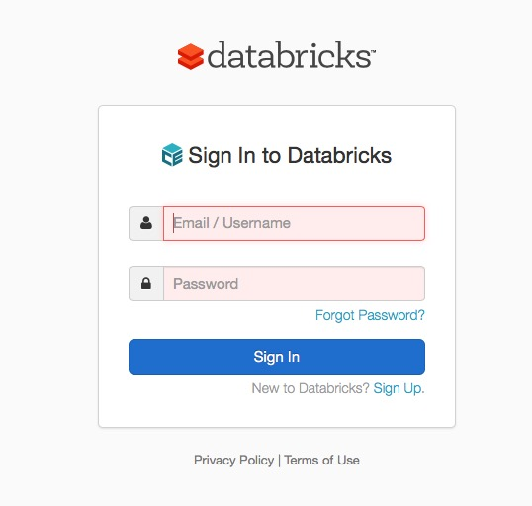

**Import the Lab Exercise:**

(At the start of lab, the instructor will show you how to import the various labs and materials into your Community Edition account – filename *Lab_09Dec17_Logistic-Regression.dbc*).

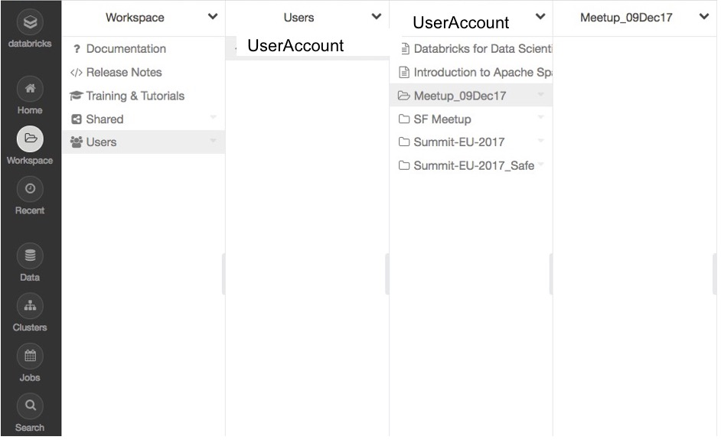

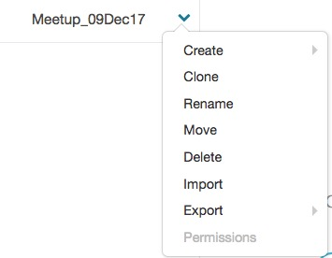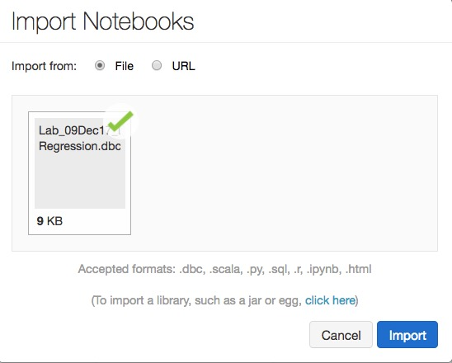

**Create a Cluster:**

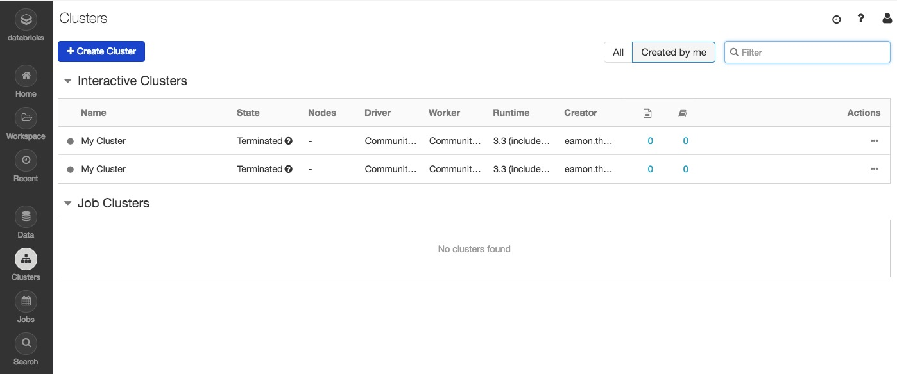

**Cluster setup Parameters (default):**

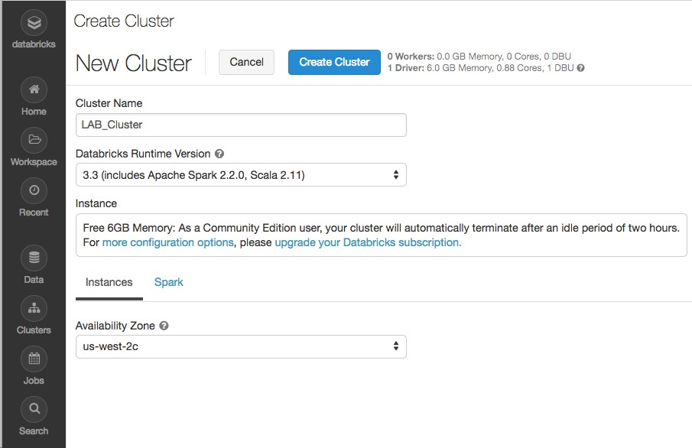

**Cluster Running:**

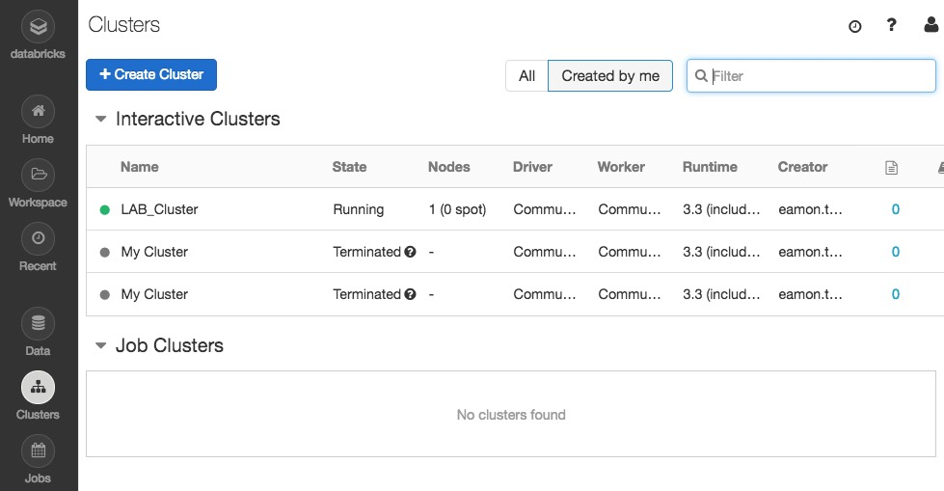

**Attach Notebook to Running Cluster:**

